**Middleware Network**

# Network Bootstrap

1. Command to bootstrap the network -

**$middleware-net/network => ./middlewareNetwork.sh up**

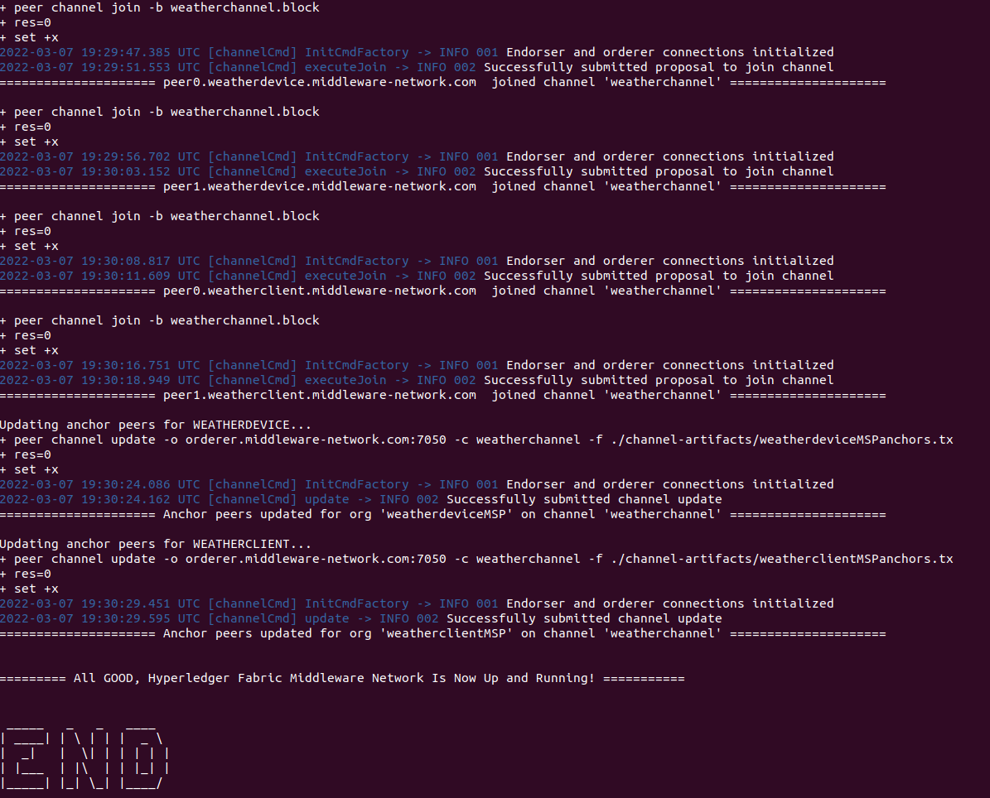

1. Command to install and instantiate chaincode
   1. Open new terminal
   2. Bash into chaincode container

**docker exec -it chaincode /bin/bash**

* 1. Check node version

**node -v**

* 1. If Node version is below 8, then install version 12

**sudo npm install -g n**

**sudo n 12.22.1**

* 1. Install the contract on chaincode and run

**npm install**

**npm run start-dev**

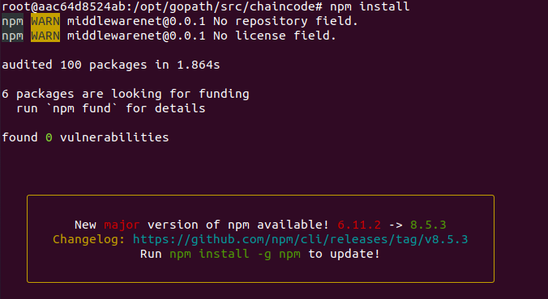

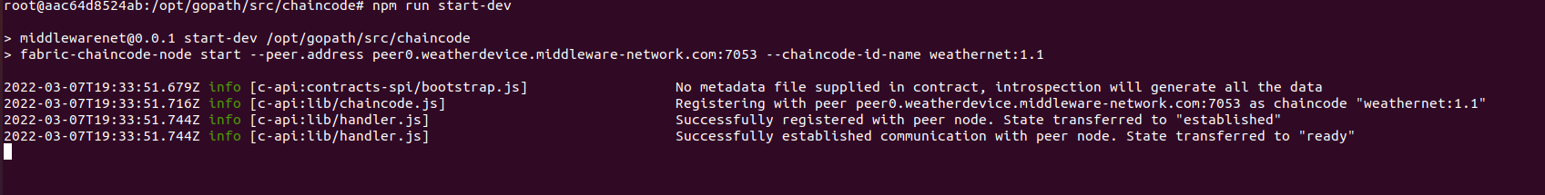

* 1. Open another tab in the terminal and run following script to install chaincode on peer containers and then instantiate

**./fabricNetwork.sh install**

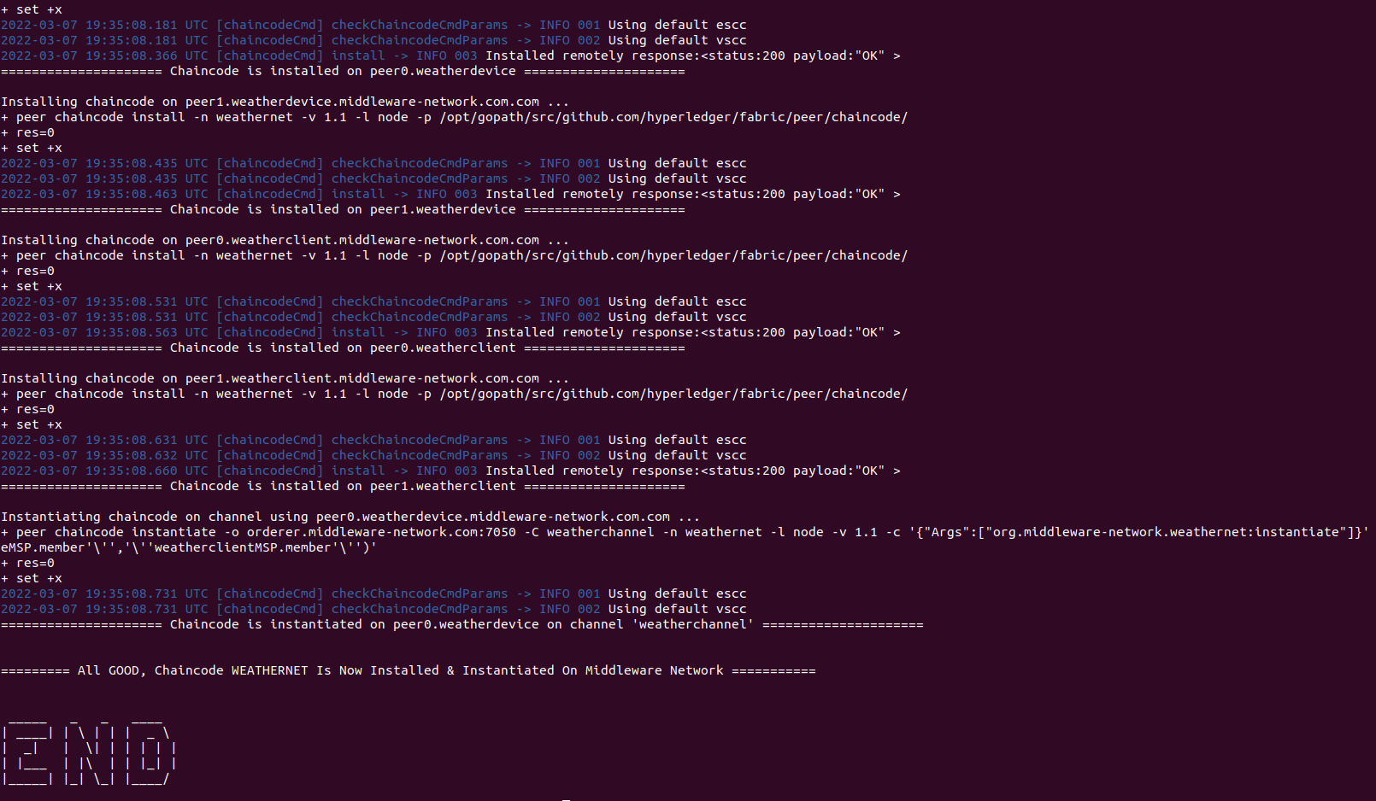

# Data Publisher

Data publisher is a NodeJs application. Start the application with following command-

**node index**

# Client Application

Client application is a NodeJs application. Start the application with following command-

**node index**

Client application starts at port 4000